PROJECT | DEPARTMENTAL STORE MANAGEMENT SYSTEM
NAME | - ZAINAB SARFRAZ  - ADEEN TARIQ  - EMAN QASIM
REG NO | - 24-NTU-CS-FL-1289  - 24-NTU-CS-FL-1242  - 24-NTU-CS-FL-1255
SEMESTER | 3rd
COURSE CODE/TITLE | CSC2073/SOFTWARE ENGINEERING AND FUNDAMENTALS
SECTION/DEPARTMENT | BSAI/CS
SUBMITTED TO | DR. MUHAMMAD ADEEL
SUBMISSION DATE


DEPARTMENTAL STORE MANAGEMENT SYSTEM
PROJECT OVERVIEW:
The Departmental Store Management System is a software application designed to automate and streamline the day-to-day operations of a medium to large trade or departmental store. It replaces traditional manual record-keeping with a fast, accurate, and user-friendly digital system.
OBJECTIVES:
- To manage store items efficiently
- To generate automatic bills
- To track inventory and stock levels
- To prevent over-selling
- To provide daily/monthly sales reports
- To maintain customer and supplier information
- To reduce manual errors and save time
STEPS IN USE CASE MODELLING:
There are the following steps of use case modelling:
Step 1: Identify and Define the Actors:
This first step is about identifying everyone and everything that interacts with your system.
- Customer
- Cashier
- Admin
- Inventory Manager
Step 2: Identify and Define the Use Cases:
This step involves determining the specific goal-oriented tasks that each actor performs using the system.
- Customer Use Cases:

These are the primary actions a shopper performs.
- Search Products
- View Product Details
- Add Product to Cart
- Remove Product from Cart
- Update Product in Cart
- View Cart
- Place order
- Cashier Use Case:

These involve handling the transactions at the checkout.
- Print Receipt
- Process Payment
- Exchange
- Apply Discount
- Admin Use Case:

These are the core maintenance and security tasks.
- Configure System Setting
- Manage User Accounts
- Inventory Manager Use Case:

These focus on managing the actual items sold in the store.
- Add new product
- Update Stock Level
- Generate Sales Report
Step 3: Construct use case model diagram:
This step is about creating the visual blueprint of your system's functionality and scope.
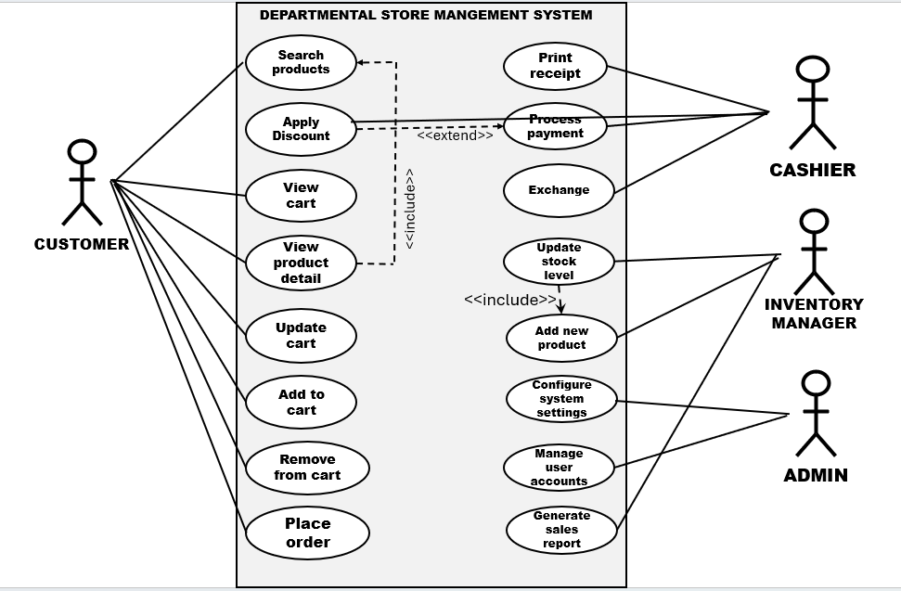
Step 4: Documents Business Requirements Use-case Narratives:
This step moves from the visual model to the detailed text documentation of each function. These narratives capture the how and why of the system's behaviour.
ELABORATED USE CASE SPECIFICATIONS:
- Search Product:
- Implementation priority: high
- Actors: Customer
- Summary: The customer submits a query (text, barcode, or category selection) to find and display a list of relevant products from the store inventory.
- Preconditions: The system is running, and the product catalogue database is accessible.
- Post conditions: A results page is displayed showing all matching products and their current pricing/availability.
- Extends: None
- Uses: None.
- Normal course of events:
- Actor: Customer enters search term (e.g., "milk").
- System: System validates the input and queries the product database.
- System: System retrieves a list of products matching "milk."
- System: System displays the search results page to the customer.
- Actor: Customer views the results.
- System: Use Case Ends.
- Alternative path:
- Path 1: The customer selects a category link (e.g., "Dairy") instead of entering text. The system retrieves all products under that category.
- Path 2: The search query returns to zero matches. The system displays a "No Results Found" message but still ends successfully.
- Exception: If the system is unable to connect to the product database in step 2, the system must display an error message (e.g., "System Error: Unable to retrieve data") and log into the failure.
- Assumption: It is assumed that the product database records are structured correctly and contain valid product IDs, names, and pricing data.
- Add item to cart:
- Implementation priority: High
- Actors: Customer
- Summary: The user selects a product and specifies a quantity to be added to the current shopping cart or transaction session.
- Preconditions: The system must be displaying a searchable list of products. The product ID must be valid and recognized by the system.
- Post conditions: The item is successfully added to the Cart/Transaction object. The current Cart Subtotal and item count are updated.
- Extends: None
- Uses: None.
- Normal course of events:
- Actor: User selects a product ID (e.g., clicks 'Add to Cart' or Cashier scans the barcode).
- System: System validates the product ID and quantity (Uses Validate Stock Availability).
- System: System retrieves the unit price (Uses Retrieve Product Price/Details).
- System: System adds the item and quantity to the Cart/Transaction object.
- System: System updates and displays the new cart subtotal.
- System: Use Case Ends.
- Alternative path:
- Path 1: If the requested quantity exceeds the available stock, the system displays an alert ("Only 5 available") and restricts the quantity added to the stock limit. Use Case ends successfully with a partial addition.
- Path 2: If the item already exists in the cart, the system simply increases the quantity count for that existing item line instead of adding a new line.
- Exception: The system fails to write the new cart details to the database, the system must display an "Order System Unavailable" message and roll back the transaction state.
- Assumption: It is assumed that the Product table contains valid and non-null values for both ProductID and UnitPrice.
- Process payment:
- Implementation priority: high
- Actors: Cashier (Primary Actor), Customer (Participating Actor).

- Summary: The Cashier records the customer's chosen payment method (cash, card, digital) and finalizes the order by successfully receiving the full amount due.
- Preconditions:
- The order (shopping cart) must be finalized.
- The total amount due (including tax and discounts) must be calculated.
- Post conditions:
- The Order record is marked as 'Paid'.
- Inventory levels for all purchased items are decremented.
- A transaction record is logged in the sales history.
- Extends: None.
- Uses: Print receipt, Update stock level
- Normal course of events:
- Actor: Selects the 'Cash' payment option.
- System: Displays the total amount due.
- System: Enters the amount of cash received from the Customer.
- System: Calculates the change due.
- Actor: Confirms the payment and gives the change to the Customer.
- System: Updates the Order record and includes Print Receipt.
- System: Use Case Ends.
- Alternative path:
- Path 1: Cashier selects 'Card', Customer inserts/taps card, external terminal approves transaction, system receives 'Approved' status.
- Path 2: Cashier scans the gift card, system verifies the balance, system deducts the amount and calculates the remaining balance due.
- Exception: If, during a card transaction, the external gateway fails to respond within the allowed time, the system displays an error message, cancels the transaction attempt, and requires the Cashier to ask for an alternative payment method.
- Assumption: It is assumed that the Cashier is correctly identified and logged in with appropriate permission to complete a financial transaction.
- Print receipt:
- Implementation priority: high
- Actors: Cashier.
- Summary: The system automatically generates a formatted, physical or digital document detailing the completed sales transaction for the customer.
- Preconditions:
- The transaction must be complete and logged as 'Paid' in the database.
- All post-payment updates (inventory decrease, sales record creation) must be finalized.
- Post conditions:
- A printable/viewable receipt document is generated.
- The Cashier terminal displays the option to start a new transaction.
- Extends: None.
- Uses: None
- Normal course of events:
- System: Triggers the receipt generation (Uses Retrieve Transaction Data).
- System: Formats the data according to the store's template (logo, store details, item list).
- System: Sends the print job command to the connected receipt printer.
- Actor: Tears off the receipt and hands it to the Customer.
- System: Confirms the print job was successfully sent and updates the screen.
- System: Use Case Ends.
- Alternative path:
- Path 1: The Cashier selects 'Email Receipt'. The system prompts the Cashier/Customer for an email address and sends the formatted receipt digitally.
- Path 2: The Customer declines a receipt. The Cashier selects 'Skip Print', and the system arches the digital receipt internally without sending a command to the printer.
- Exception: If the printer is offline, out of paper, or experiences a communication failure in Step 3, the system must display a High-Priority Error notification to the Cashier and offer an alternative path (like emailing the receipt).
- Assumption: It is assumed that the physical receipt printer is connected to the system, powered on, and contains sufficient paper/ink supplies.
- Update Stock Level:
- Implementation priority: high
- Actors: Inventory Manager
- Summary: Allows the Inventory Manager to increase, decrease, or adjust product stock levels in the system.
- Preconditions:
- Product must exist in the database
- Inventory manager must be logged in.
- Post conditions:
- Updated stock quantity is saved.
- Updated stock is reflected in the product list.
- Extends: None.
- Uses: None
- Normal course of events:
- Actor: Selects a product.
- Actor: Enters new stock quantity.
- System: Update stock level.
- System: Displays confirmation.
- System: Use Case Ends.
- Alternative path:
- Actor cancels the update.
- Exception:
- Product not found.
- Invalid stock quantity.
- Assumption:
- Inventory data is accurate.
- Actor has updated permission.

- Apply discount:
- Implementation priority: High
- Actors: customer/cashier
- Summary: Allows applying discount or coupon to an order or cart.
- Preconditions:
- Active card or order must exist.
- Discount must be valid.
- Post conditions:
- Discount applied to total price.
- Updated price is shown.
- Extends: Process Payment
- Uses: Validate coupon
- Normal course of events:
- Actor: Enter discount code.
- System: Check validation.
- System: Applies discount.
- System: Update total amount.
- System: Use Case Ends.
- Alternative path:
- Actor removes applied discount.
- Exception:
- Invalid discount.
- Discount not applicable to items.
- Assumption:
- Discount rules are pre-configured.
- Handle return/Exchange:
- Implementation priority: high
- Actors: cashier
- Summary: Allows returning or exchanging purchased items.
- Preconditions:
- Original receipt or order must exist.
- Cashier logged in.
- Post conditions:
- Item returned or exchanged.
- Refund or updated payment processed.
- Extends: None
- Uses: Process payment, Update stock level.
- Normal course of events:
- Actor: Scans returned item.
- System: Verifies purchase.
- Actor: Selects return or exchange.
- System: Processes exchange.
- System: Use Case Ends.
- Alternative path:
- Store credit instead of refund.
- Partial return.
- Exception:
- Receipt not found.
- Return period expired.
- Assumption:
- Customer’s item is in acceptable condition.
- Generate sales report:
- Implementation priority: High
- Actors: Admin
- Summary: Generates daily, weekly, or monthly sales reports.
- Preconditions:
- Sales data must exist.
- Admin logged in.
- Post conditions:
- Sales report generated.
- Report available for view or download.
- Extends: None
- Uses: None
- Normal course of events:
- Actor: Selects report type.
- System: Generates report.
- Actor: Selects data range.
- System: Displays report.
- System: Use Case Ends.
- Alternative path:
- Actors download report.
- Actor print report.
- Exception:
- No sales data available.
- Assumption:
- Sales records are up to date.
- Manage user accounts:
- Implementation priority: high
- Actors: Admin
- Summary: Admin creates, updates, or deletes system user accounts.
- Preconditions:
- User stored in database.
- Admin logged in.
- Post conditions:
- User accounts are modified as requested.
- Extends: None
- Uses: None
- Normal course of events:
- Actor: Selects user account options.
- System: Save changes.
- Actor: Add/edit/delete user.
- System: Shows confirmation.
- System: Use Case Ends.
- Alternative path:
- Deactivate the account instead of deleting.
- Exception:
- Invalid user details.
- Username already exists.
- Assumption:
- Admin has full privileges.
- Add new product:
- Implementation priority: high
- Actors: Inventory manager
- Summary: Adds a new product including name, price, category, and initial stock.
- Preconditions:
- Inventory manager logged in.
- Post conditions:
- Initial stock level created.
- Product stored in product database.
- Extends: None
- Uses: Update stock level
- Normal course of events:
- Actor: Enters product information.
- System: Save product.
- Actor: Enters initial stock.
- System: Shows confirmation.
- System: Use Case Ends.
- Alternative path:
- Actor cancels adding products.
- Exception:
- Duplicate product name.
- Invalid data format.
- Assumption:
- Product information is correct.
- Configure system settings:
- Implementation priority: High
- Actors: Admin
- Summary: Allows changing system settings like tax rates, discounts, and security settings.
- Preconditions:
- Admin logged in.
- Post conditions:
- New settings applied.
- Extends: None
- Uses: None
- Normal course of events:
- Actor: Open settings.
- System: Save configuration.
- Actor: Modifies values.
- System: Shows confirmation.
- System: Use Case Ends.
- Alternative path:
- Actor resets setting to default.
- Exception:
- Invalid input value.
- Assumption:
- Using settings does not brake system functionality.
- View product details:
- Implementation priority: High
- Actors: Customer
- Summary: Shows product information such as price, description, stock, and image.
- Preconditions:
- Product must exist.
- Post conditions:
- Product details displayed to customers.
- Extends: None
- Uses: Search product.
- Normal course of events:
- Actor: Selects product.
- System: Loads product details.
- System: Displays full information.
- System: Use Case Ends.
- Alternative path:
- Show similar products.
- Exception:
- Product unavailable.
- Assumption:
- Product database is updated.
- Update cart:
- Implementation priority: High
- Actors: Customer
- Summary: Allows changing quantity, removing items, or updating content in the shopping cart.
- Preconditions:
- Cart must exist.
- Customers must be logged in.
- Post conditions:
- Updated cart saved.
- Extends: View Cart(optional)
- Uses: None
- Normal course of events:
- Actor: Open carts.
- Actor: Changes quantity or removes items.
- System: Update cart.
- System: Displays new total.
- System: Use Case Ends.
- Alternative path:
- Save cart for later.
- Exception:
- Invalid quantity.
- Out of stock.
- Assumption:
- Items in cart have valid prices.
- View cart:
- Implementation priority: High
- Actors: Customer/Cashier
- Summary: Displays all items currently added to the cart.
- Preconditions:
- Cart exists.
- Post conditions:
- Cart is shown to users.
- Extends: None
- Uses: None
- Normal course of events:
- Actor: Open carts.
- System: Load cart items.
- System: Displays total price.
- System: Use Case Ends.
- Alternative path:
- Redirect users to continue shopping.
- Exception:
- Cart is empty.
- Assumption:
- Cart contents are valid.
- Place order:
- Implementation priority: High
- Actors: Customer
- Summary: Customer places a final order after reviewing the cart.

- Preconditions:
- Valid cart.
- Payment method available.
- Post conditions:
- Order created in system.
- Payment processed.
- Order marked complete.
- Receipt generated.
- Extends: None
- Uses: Process payment, print receipt
- Normal course of events:
- Actor: View carts.
- Actor: Selects payment method.
- System: Processes payment.
- System: Confirm order.
- System: Prints receipt.
- System: Use Case Ends.
- Alternative path:
- Customer selects a different payment method.
- Exception:
- Payment failure.
- Items go out of stock.
- Assumption:
- Customers’ information is valid.
- Remove item from cart:
- Implementation priority: High
- Actors: Customer/Cashier
- Summary: The user removes a selected item entirely from the current shopping cart or transaction session.
- Preconditions:
- The item to be removed must currently exist in the shopping cart/transaction.
- The order must not be marked as “Paid” or “Closed”.
- Post conditions:
- The item line is successfully deleted from the Cart object.
- Total recalculated.
- Extends: None
- Uses: None

- Normal course of events:
- Actor: View current carts.
- Actor: Selects the ‘Remove’ option next to a specific item line.
- System: User confirmation for removing the item from the list.
- Actor: User confirms the removal.
- System: Removes the item from the cart.
- System: Displays the updated cart.
- System: Use Case Ends.
- Alternative path:
- Zero quality removal.
- Exception:
- Transaction is already closed.
- Assumption:
- Inventory is not affected until payment.

THE END

